Year 2 Geography autumn 1 – Weather and Seasons Knowledge Organiser
Key Knowledge:
- To describe different types of weather and understand changes around us.
- To observe the weather and understand data from pictures, words and symbols.
- To understand why weather changes and now that different types of wind bring about these changes.
- To understand that there are four seasons in the U.K.
- To know about parts of the U.K and its capital cities and talk about the weather there.
- To focus on the local area, as well as looking at the wider perspective of the UK.
- To observe and spot seasonal patterns and talk about changes by using weather related vocabulary.

Key Vocabulary:
weather – is the day to day or hour to hour change in the atmosphere.
season – A part of a year. There are four.
wind – the movement of air caused by the uneven heating of the sun on the Earth and its own rotation.
seasonal weather patterns – seasons characterized by distinguishing climate.
weather forecast– a prediction of weather conditions using science and technology.
satellite view – A birds eye view.

Key skills: Identify season and daily weather patterns in the UK. Develop locational and place knowledge about their locality and the UK as a whole. Use and construct basic weather symbols in a key.

Do you remember learning? In Year 1 you looked at animals in hot and cold places.


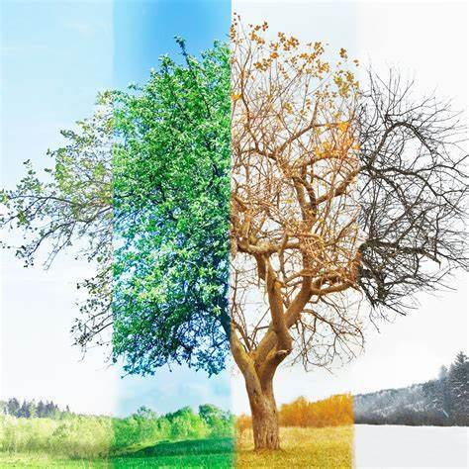

Can you recognise any of the weather symbols seen below?



