Year 1 Spring 2– People and their communities Knowledge Organiser
Key Knowledge:
- We go on four different world journeys. Starting with their local area, they then look at coastal, rainforest, dry (desert) and world city locations.
- We are going to go on virtual and imagined journeys to explore similarities, compare and contrast.
- We are going to move beyond just our locational knowledge to a deeper understanding of place knowledge.
- We are going to explore dry deserts-the driest and most barren places on Earth to tropical rainforests that get lots of rain. Many animals and plants are found here.
- The oceans are wide and deep and filled with saltwater-many sea creatures live in the oceans.
- Coasts are the land along the sea. The boundary of a coast, where land meets water, is called the coastline. Waves, tides, and currents help create coastlines.
- Billions of people live on Earth. Some live in villages and the countryside, others live and work close together in towns and cities

Key Vocabulary:
barren –dry and bare with few plants
tropical – very hot
adapted – having special features that make a plant or animal able to survive in a place
ocean– is a huge body of saltwater.
sea – A body of saltwater of second rank.
coastline – where the sea and the land join. They are adjacent to each other.
continent – a large solid area of land. There are seven continents in the world.
country– a land lived in by people.
compass points – directions listed on a magnetic compass. The four main points being, North, East, South, West

Do you remember learning? In reception, we compared and contrasted our recycling system to that in Germany.
In autumn, we explored our local area.
Key skills:
Compare our local area to distant locations around the world.
To research and explore specific oceans and lands that Earth by going on virtual journeys from busy cities to dense, steamy rainforests.

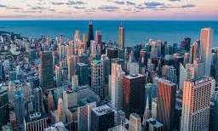
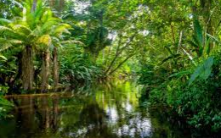
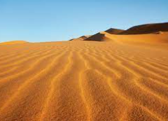
Describe what you saw on your journey around the world.


