Year 1 History Autumn 2 – Shadwell over time Knowledge Organiser
Key Vocabulary:
River Thames – the river that flows through London.
Shadwell Basin – a dip in the land that drains water from the land (like a bowl of water)
Watney market – community market selling a diverse range of fruit, vegetables and more
past-something that has happened or was done in the past.
present-happening right now

Key Knowledge:
- Life in an area of London (Shadwell) was different in the past to my life now.

- By exploring the changes in familiar places such as Watney Market, the fire station, the River Thames, Shadwell Basin, we will see that people lived differently in the past. We will notice that these places looked different.

- By getting into role, we will explore how the people of Shadwell lived over the years and notice the similarities and differences to how we live today.

- We will notice that there are changes within the environment that we live in now and that human features have shaped Shadwell to be what it is today.

Key skills:
To use words and phrases like: old, new and a long time ago.
To recognise and discuss examples of things that are different in my life from that of the past.
To answer questions using a range of artefacts/ photographs provided.
To compare by discussing things that have remained the same and things that have changed.

Do you remember learning?
In autumn 1, we were exploring our local area and using maps to locate Shadwell and explore the famous landmarks that make our area a very special place.
Now that you know about the locality and physical/human features of Shadwell, we are going to explore how this area has changed over time.

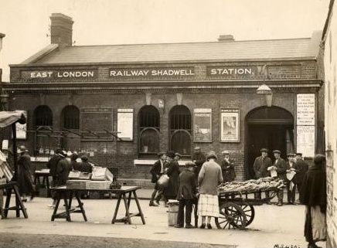
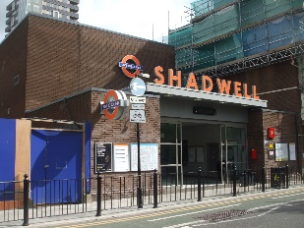
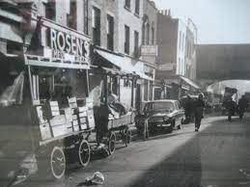

Shadwell: Describe what has remained the same.

