Year 1 Geography Autumn 1 – Our Local area Knowledge Organiser
Key Vocabulary:
explorer – a person who explores unfamiliar territory.
map: a picture representation of an area of land or sea showing physical features, cities, roads, etc.
birds eye view: a general view from above.
directions: a course along which someone or something moves
landmarks: an object or feature of a landscape or town that is easily seen and recognized from a distance.
human features: human characteristics of a place come from human ideas and actions.
physical features: anything that is on Earth naturally.
location: a particular place or position.

Key Knowledge:
- To use fieldwork and observational skills to explore the school and its grounds
- To draw/use a basic map of our local area and identify the key features.
- To use the language forwards, backwards, left, right, north, south, east, west to navigate around school.
- To identify the significant landmarks of our local area.
- To compare journeys and landscapes and understand near/far, often/ rarely.
- To learn about maps, map-making and symbols.

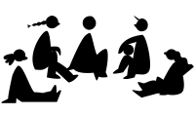
Key skills: Using Maps
- Use a simple picture map to move around the school and local area.
- Use a relative vocabulary such as bigger, smaller, like, dislike
- Use directional Language such as near, and far, up and down, left and right, forwards and backwards.

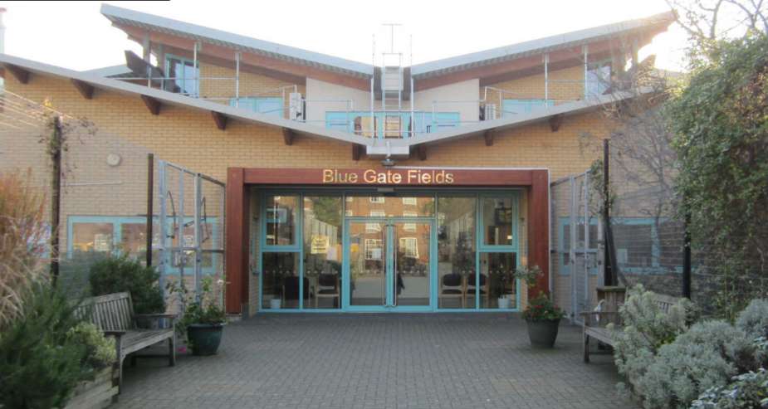
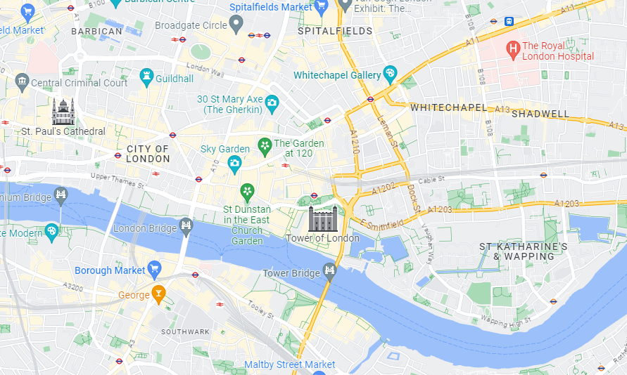
Do you remember learning? In Reception, we looked at different occupations and ways of life.
We explored some of the things that make us unique and talked about some of the similarities and differences in relation to friends or family. We discussed and asked questions about aspects of our familiar world such as the place where they live and the natural world.

Can you draw/describe your route to school?

