 | Week 1 | Week 2 | Week 3 | Week 4 | Week 5 | Week 6 | Week 7 | Week 8 | Week 9 | Week 10 | Week 11 | Week 12 | Week 13 | Week 14
Autumn | Getting to know the children |  |  | Numberblocks: Series 1 Episodes 1-11
Spring | Numberblocks: Series 1 Episodes 12-15 |  |  |  | Matching and sorting  Comparing size, mass and capacity Exploring patterns |  |  |  | Comparing numbers  Composing numbers  2D shapes
Summer | Representing numbers  Subitising to 5  Pattern |  |  |  | One more/ one less  2D shapes |  |  |  | Separating a group in different ways  Measuring  Positional language |  |  |  | Problem Solving
Overview 2022-2023
Nursery

Reception
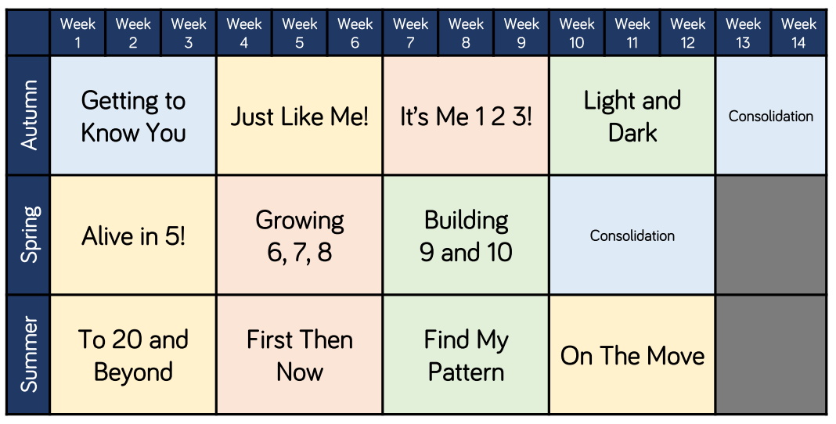

Year 1
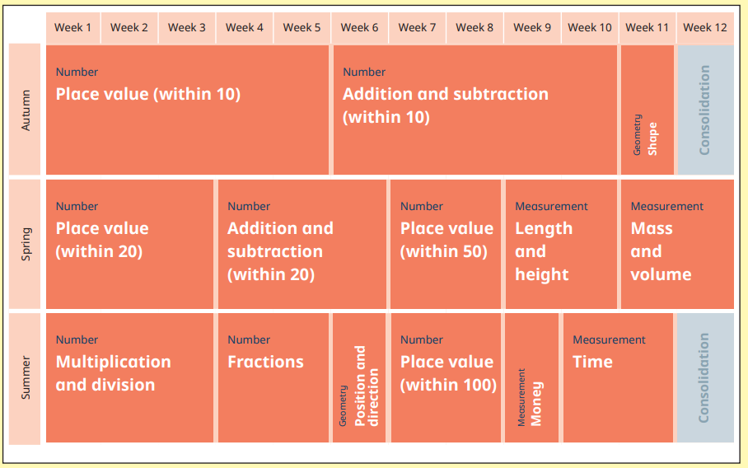

Year 2
 | Autumn 1  7wks | Autumn 2  7wks | Spring 1  6wks | Spring 2  6wks | Summer 1  6wks | Summer 2  7wks
Week 1 | Number:  Place Value | Geometry and Shape | symmetry | Position and Direction | Number: Fractions | Number: Fractions
Week 2 | Number:  Place Value | Statistics | Position, Direction and Time | Number: Addition and Subtraction (missing number) | Number: Fractions | Problem Solving
Week 3 | Number: Addition and Subtraction | Statistics | Time | Measurement mass and capacity | Revision: see Hamilton revision week. | Investigation: Measurement and Time
Week 4 | Number: Addition and Subtraction | Number: Addition and Subtraction  (word problems and number line)  +  Adding and subtracting money | Number: Multiplication and Division | Geometry and shape  Measurement: Temperature | SATs | Investigation  (ncetm)
Week 5 | Measurement: Money (making amounts) |  | Number: Multiplication and Division | Number: Multiplication and Division | SATs | Investigation  (ncetm)
Week 6 | Measurement:  Money  (blank number line) | Measurement: Mass and Capacity  Wk 7: Length and Height | Measurement: Money (making amounts) | Number: Multiplication and Division Problem Solving | Maths games  (see Hamilton) | Investigation  (ncetm)
Week 7 | Shape | Time |  |  |  | Maths Games

