Humanities in the spring term
What a great term it has been with the children in Blue Gate Fields Infant School, trying out some new topics.
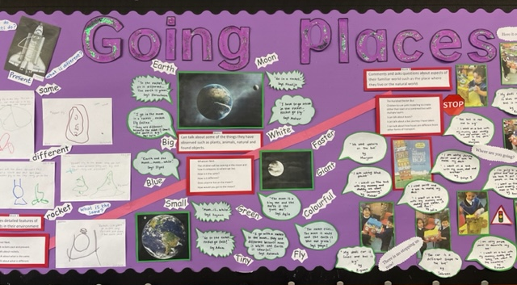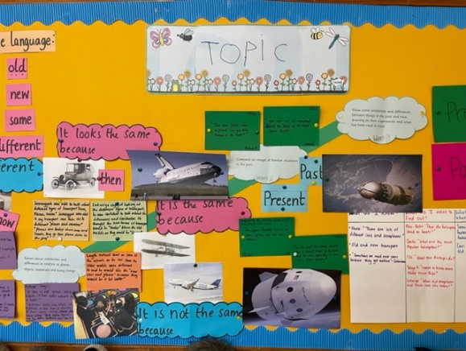
In Early Years they looked at the topics of ‘Transport’ and ‘Going places’.
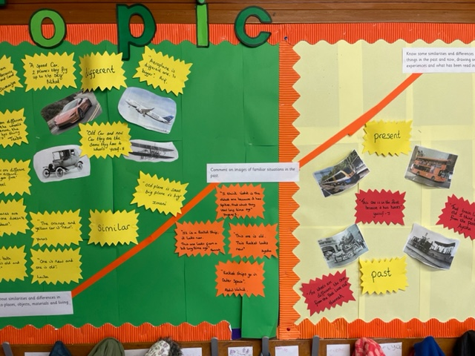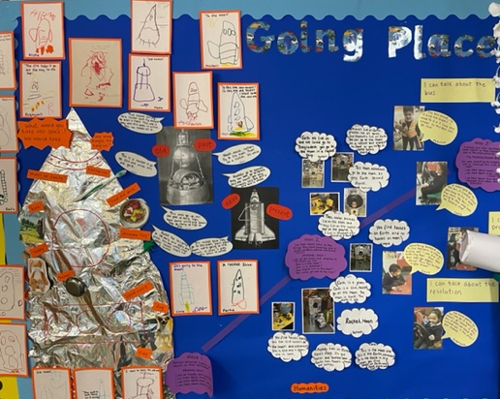
The children enjoyed the topics very much and sharing their knowledge about past and present concerning transport and going places, as in on a spaceship.
Early Years Cont’d
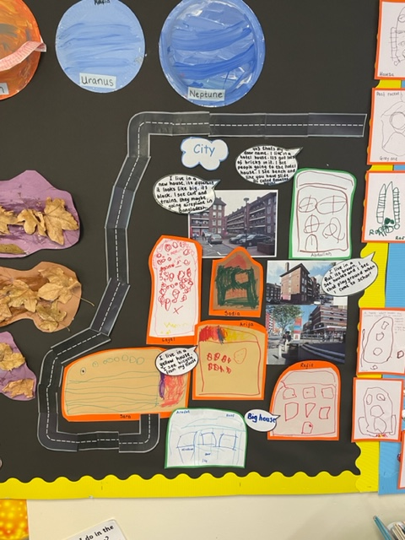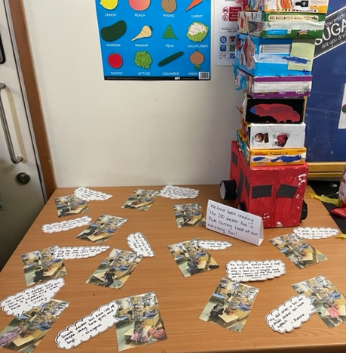
Map work and transport model making took place within the topics too!
In Year 1 the children learnt about ‘People and Communities, and ‘Toys, Past and Present’.
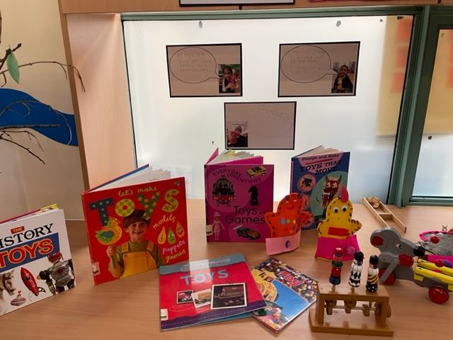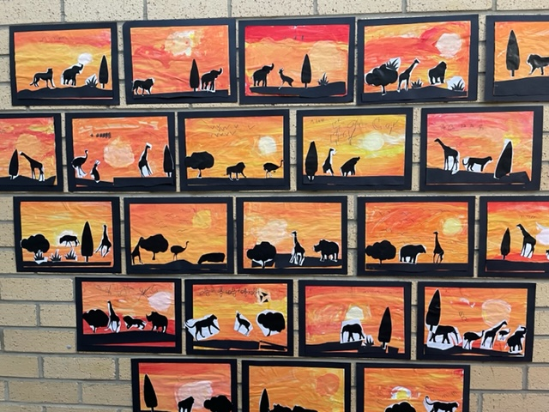

Children looked at the chronology of toys from grandparents to now and with peoples and communities, from local and faraway places as in Kenya.
In Year 2 the children have learnt about
‘Christopher Columbus’ and ‘Journeys ~ Food’.
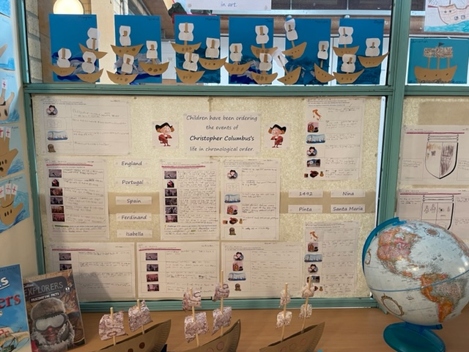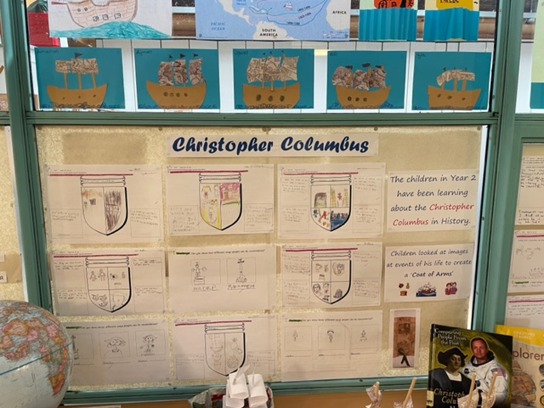
In history the children have been learning about the chronology of significant events in Christopher Columbus’s life and whether he, was deemed to be a hero or not.
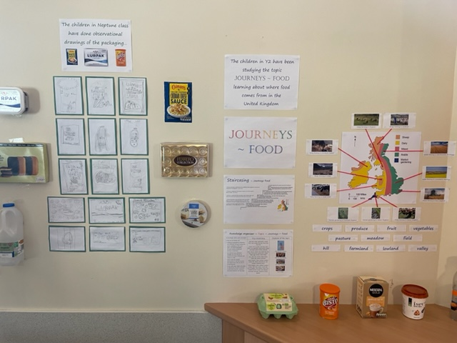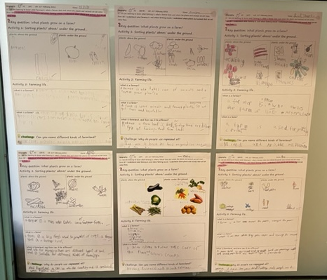
In the Journeys ~ Food topic the children learnt about different kinds of food, processing of food and where farming and traditional foods can be found in the UK.

