Humanities in the autumn term
We celebrated Black History Month in October.
It is important to celebrate diversity.
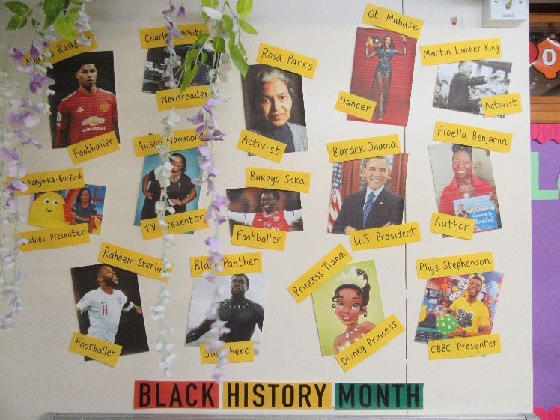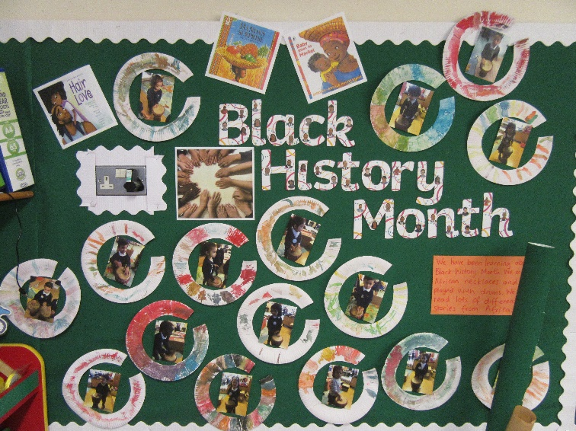
In Early Years they looked at the topics of ‘Ourselves’ and ‘Families’.
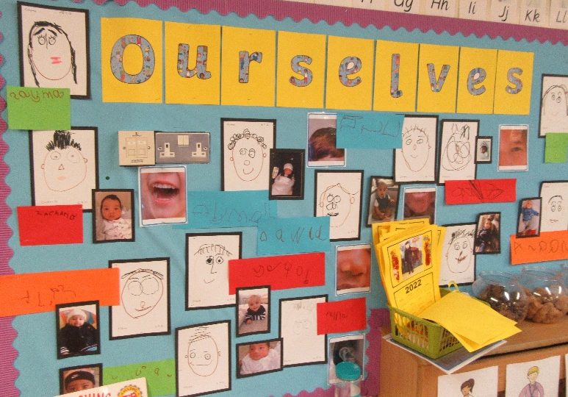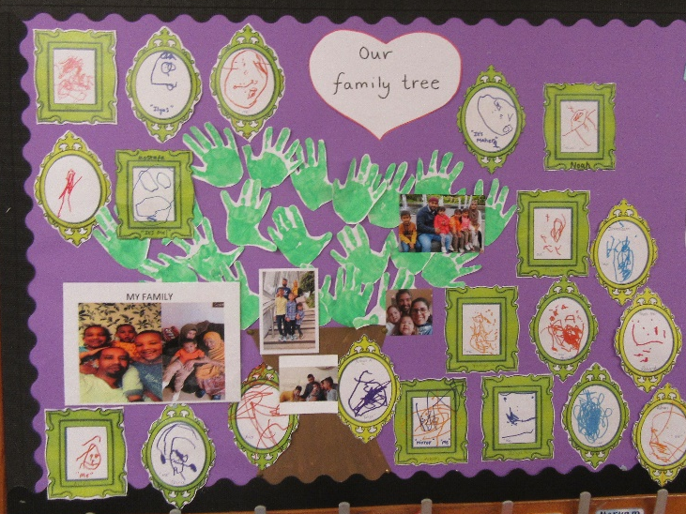
The children enjoyed this topic very much and sharing about themselves when very young and who is in their families.
In Year 1 the children learnt about their local environment of Shadwell.
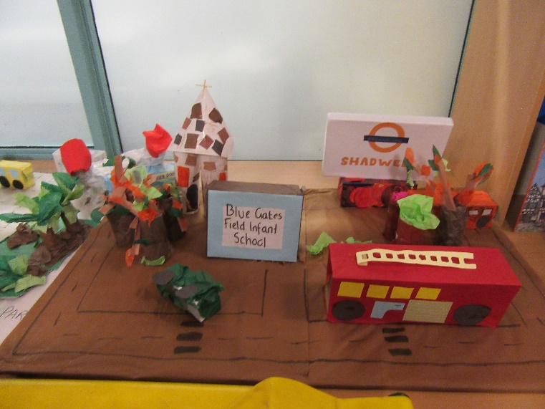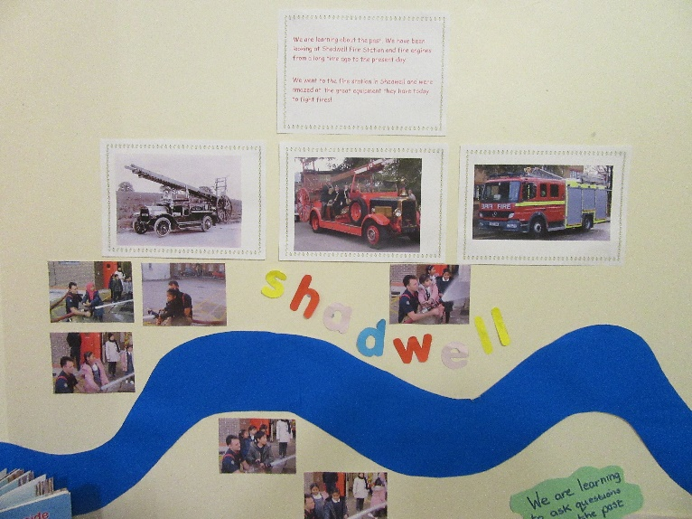

Both from a geographical point of view and an historical one too. Skills included mapping and the history of Shadwell Fire Station.
In Year 2 the children learnt about
‘The Great Fire of London’
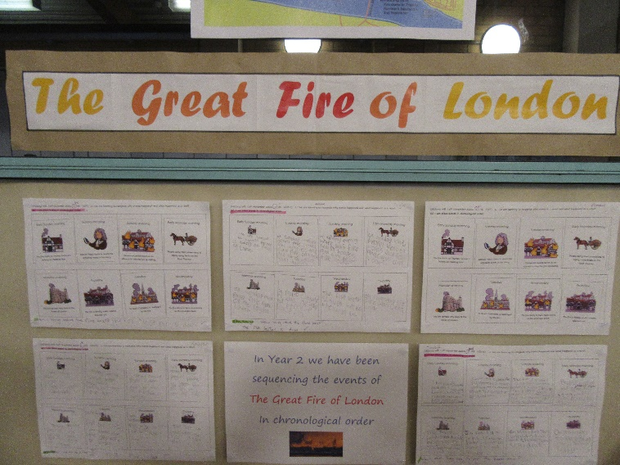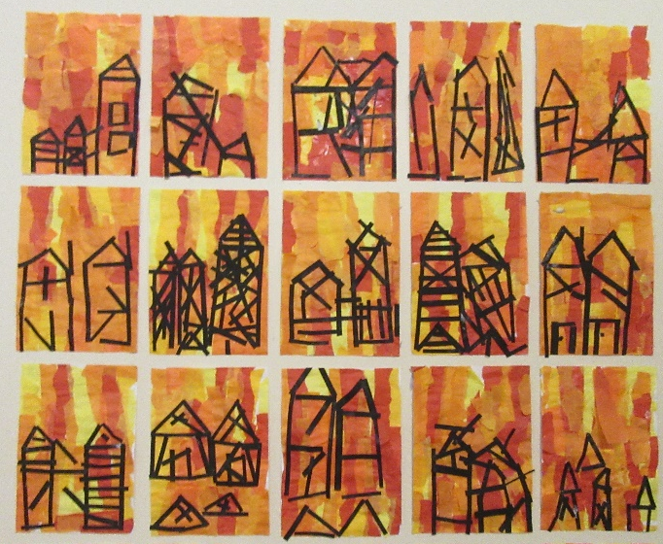
And the chronology of the fire events.

